Power Gauge – Mild HEV – CGEA 1.3

Functional Description

The IPC shall provide a gauge on an Information On-Demand (IOD) screen to display the required information. The gauge shall be accessible via menu or similar navigation structure consistent with other driver assistance IOD screens. This gauge shall be capable of indicating electrical traction power (not actual electrical power) flowing throughout the system in the following situations:

- When the engine is off or auto-stopped, the mHEV system does not absorb/deliver power. In this case, the gauge shall reflect the display that the power flow to is 0.
- The amount of electric power the vehicle is recuperating with the BISG during deceleration events shall be displayed.

The mHEV Power Gauge correlates the EffWhlLvl2_PC_Dsply, MildHybStat_D_Dsply and the Operational Mode to generate a position on bar graph.The calculation of the power shall generate an intuitive output such that reflects how the driver’s interaction with the vehicle affects the behavior of the mHEV system. This output shall be split according to the following rules:

- Negative values: Energy flows from the e-machine towards the battery/DCDC converter.
- Positive values: Power is delivered from the electric system to the wheels.

  - Negative
BISG
Electric system
Negative Torque
Energy recuperated
Negative (-)

- Positive
BISG
Electric system
Positive Torque
Energy recuperated
Positive (+)

Starting from v1.3, Icons beside the gauge IOD on right/left side of gauge are decoupled from gauge fill signal (EffWhlLvl2_PC_Dsply) and tagged to RTT signal (MildHybStat_D_Dsply). Updated behavior is explained in section 1.3.5.1.4. No Change in HMI layout.

Interfaces

Interface Context Diagram (I/O Block Diagram)

Figure 1 mHEV Power Gauge Context Diagram

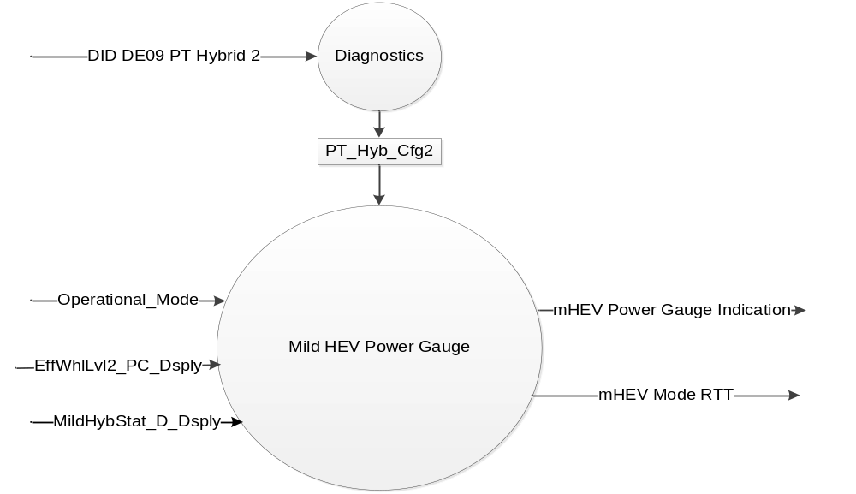

Inputs

- Internal:
- Operational_Mode

- MUX signals on the CAN Bus

EffWhlLvl2_PC_Dsply Signal*
Signal Name | Size (bits) | Detail | Units | Res. | Offset | State Encoded | Min | Max
EffWhlLvl2_PC_Dsply | 10 | Driver Requested Vehicle Power | % | 0.2 | -102.2 |  | -102.2  (0x0) | 102.4 (0x3FF)
* This is a signed signals.
Signal values from 0x0 through 0xA are to be treated as Invalid Value
Signal values of 0x0B through 0x3F3 map to -100% through 100%
Signal values from 0x3F4 through 0x3FF are to be treated as Invalid value

MildHybStat_D_Dsply Signal
Signal Name | Size (bits) | Detail | Units | Res. | Offset | State Encoded | Min | Max
MildHybStat_D_Dsply | 3 |  | SED | 1 | 0 |  | 0  (0x0) | 7  (0x7)
 |  | Off |  |  |  | 0x0
 |  | System Error |  |  |  | 0x1
 |  | SystemInhibited |  |  |  | 0x2
 |  | Boost |  |  |  | 0x3
 |  | Assist |  |  |  | 0x4
 |  | Charge |  |  |  | 0x5
 |  | Recovery |  |  |  | 0x6
 |  | Not Used |  |  |  | 0x7

Outputs

mHEV Power Gauge Indication
mHEV Mode RTT

Function/Performance

Operational Modes

Mode | Differentiating Vehicle Conditions
Sleep Mode | Power Gauge pointer at ‘Rest Position’
Limited Mode | Power Gauge pointer at ‘Rest Position’
Normal Mode | Power Gauge pointer at “Power Gauge Indication”
Crank Mode | Power Gauge pointer at “Power Gauge Indication”

Operational Modes Voltage Levels

Refer to the Cluster Features table located in the Operational Modes and Voltage Range Strategies Section of this SPSS.

Human-Machine Interface

Visual

Indicator Graphics / Display Format

mHEV Power Gauge Example Graphics

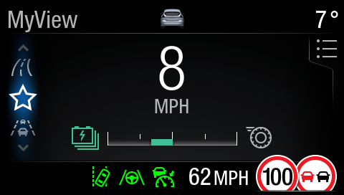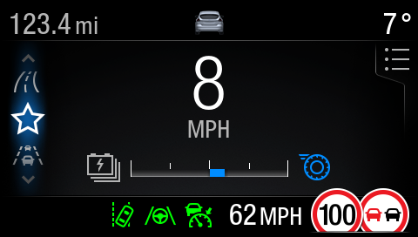
Charge Assist
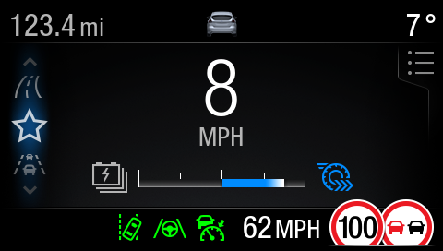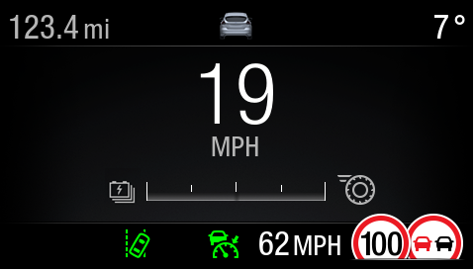
Sport Invalid/Missing

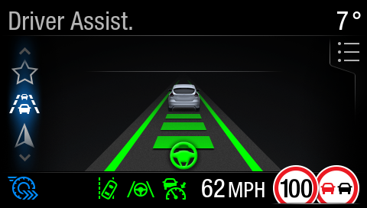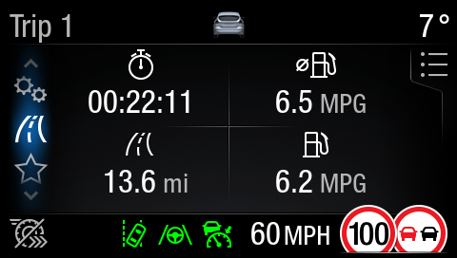
The symbols are displayed in the lower status bar if the user selected a screen different from the mHEV gauge view.

(*) Icons used in these examples are placeholders. Please refer Wallpapers for final HMI.

The drawing below shows an example of the three different modes transmitted by the CAN signal: regeneration (from -100% to 0), assist (0% to 50%) and sport boost (50% to 100%). The IPC is to be capable of differentiate these three situations and update the gauge accordingly.

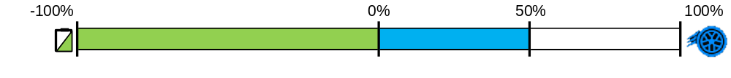

Variant with Sport Mode

(*) Colors are for orientation purposes. The final implementation will be subject to internal/external
validation.

Above are example graphics. Actual graphics are to be provided by Ford HMI or Studio and approved by the DI Application for each program.

Indicator Color Coordinates

As per studio approved design.

Indicator Characteristics

As per studio approved design.

Audio

None.

Switch Control Logic

None

System Accuracy

- The mHEV power gauge must track all dynamic power requests with a smooth pointer movement with no greater than 300 millisecond lag and an overshoot/undershoot not to exceed 2% of full scale.
- The Power gauge pointer shall traverse to at least 90% of the travel to rest position within 1000mS and complete travel to rest position within an additional 300mS when transitioing to "Sleep Mode" or "Limited Mode.

Operation: Performance and Functional

Subsystem Algorithm Flowchart / State Diagram

mHEV Power Gauge Process
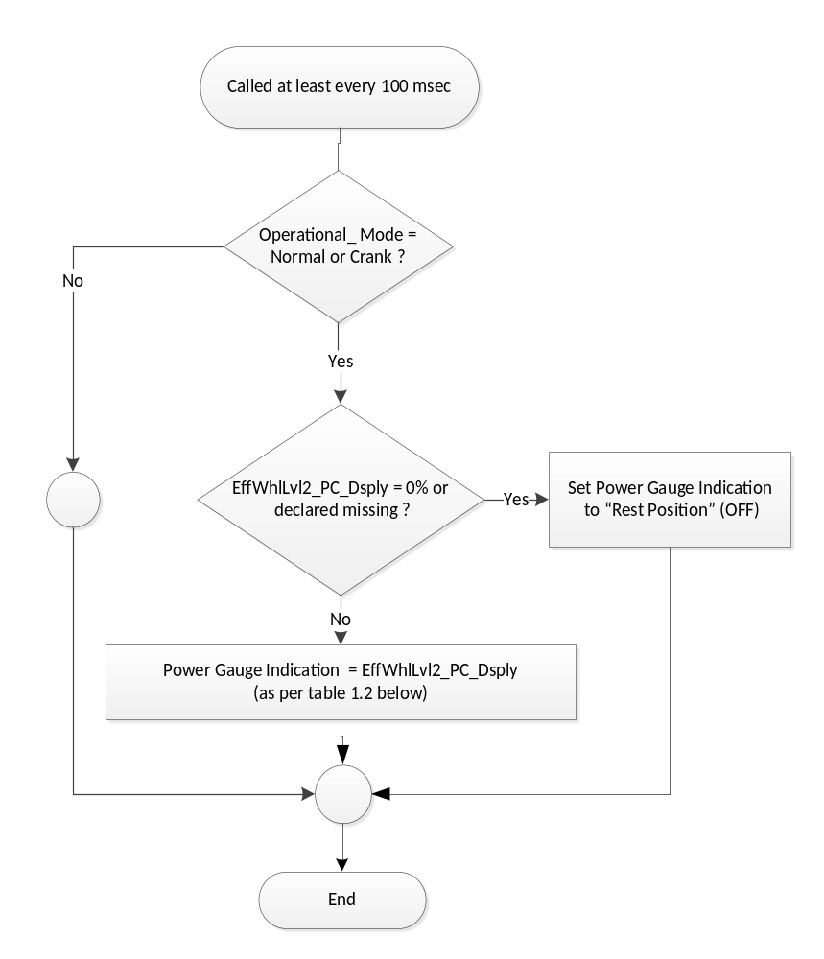

mHEV Gauge Indication

Operational_Mode | PT_Hyb_Cfg2 | EffWhlLvl2_PC_Dsply  Signal | Power Gauge  Pointer Position | Power Gauge Indication
Normal/Crank | mHEV | 0x0 – 0xA | Empty | The default (0) will be used. The gauge will not display anything.
Normal/Crank | mHEV | 0xB – 0x1FE | Negative  (Green) | Show bar on left side of Gauge. Fill piecewise linear.
Normal/Crank | mHEV | 0x1FF | Rest | Gauge with No Fill
Normal/Crank | mHEV | 0x200 – 0x2F9 | Color  (Blue) | Show bar on Right Side of Gauge. Fill first half of positive side. Piecewise Linear
Normal/Crank | mHEV | 0x2FA – 0x3F3 | Color  (Blue + White) | Show bar on Right Side of Gauge. Fill second half of positive side. Piecewise Linear
Normal/Crank | mHEV | 0x3F4 – 0x3FF  /Missing | Rest | Gauge with No Fill
All Other Cases |  |  | Rest | Gauge with No Fill

mHEV RTT Matrix

Operational_Mode | PT_Hyb_Cfg2 | MildHybStat_D_Dsply | Power Gauge  RTT | RTT  Graphics | RTT ICON ID | RTT  Color
Normal/  Crank | mHEV | 0 = Off | No response expected | OFF | NA | OFF
Normal/  Crank | mHEV | 1 = System Error | No response expected | OFF | NA | OFF
Normal/  Crank | mHEV | 2 = Inhibited | On–Unique  “Boost inhibited icon” |  | M.009 | Gray
Normal/  Crank | mHEV | 3 = Boost | On – Unique  “Boost icon” |  | M.008 | Blue
Normal/  Crank | mHEV | 4 = Assist | On – Unique “Assist icon” | 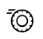 | M.007 | Blue
Normal/  Crank | mHEV | 5 = Charge | On– Unique “Charge icon” |  | M.006a | Green
Normal/  Crank | mHEV | 6 = Recovery | No response expected | OFF | NA | OFF
Normal/  Crank | mHEV | 7 = Not Used | No response expected | OFF | NA | OFF
All Other Cases |  |  | No response expected | OFF | NA | OFF

The instrument cluster shall hide the RTT while the mHEV Power Gauge is being displayed. Boost not available (MildHybStat_D_Dsply = SystemInhibited(0x2)) is the only exception where “Boost inhibited icon” shall always be displayed (even when the mHEV Power Gauge IOD is selected).

mHEV Power Gauge Icons
In the IOD page, decoupled the gauge pointer position and the icons at the ends, so that EffWhlLvl2_PC_Dsply decides gauge pointer position and the icons are driven by MildHybStat_D_Dsply. The icon behaviour is shown in the matrix below.

Operational_Mode | PT_Hyb_Cfg2 | MildHybStat_D_Dsply | RTT  Graphics | RTT  Color | IOD Left End Icon | IOD Right End Icon  Color | IOD Right End Icon | IOD Right End Icon  Color
Normal/  Crank | mHEV | 0 = Off | OFF | OFF |  | Grey |  | Grey
Normal/  Crank | mHEV | 1 = System Error | OFF | OFF |  | Grey |  | Grey
Normal/  Crank | mHEV | 2 = Inhibited |  | Gray |  | Grey |  | Grey
Normal/  Crank | mHEV | 3 = Boost |  | Blue |  | Grey |  | Blue
Normal/  Crank | mHEV | 4 = Assist |  | Blue |  | Grey |  | Blue
Normal/  Crank | mHEV | 5 = Charge |  | Green |  | Green |  | Grey
Normal/  Crank | mHEV | 6 = Recovery | OFF | OFF |  | Grey |  | Grey
Normal/  Crank | mHEV | 7 = Not Used | OFF | OFF |  | Grey |  | Grey
All Other Cases |  |  | OFF | OFF |  | Grey |  | Grey

Operation Description (supports algorithm flowchart /state diagram)

- The IPC shall provide a gauge on an Information On-Demand (IOD) screen to display the required information. The gauge shall be accessible via menu or similar navigation structure consistent with other driver assistance IOD screens.

- The gauge shall be configured and scaled to display the power the mHEV system based on the signal EffWhlLvl2_Pc_Dsply received via CAN.

- The cluster shall be capable of displaying three regions in the gauge depending on the value of the CAN signal:
  - Charge: From -100% to 0%
  - Assist: From 0% to 50%
  - Boost: From 50% to 100%

- A threshold shall be set to separate assist and boost modes. This threshold, set at 50%, is not to be sent by the ECM/PCM and its value shall be saved internally in the IPC as a constant.

- The differentiation of the three states in which the mHEV system can be in shall be compatible with both color and monochrome based displays.

- The instrument cluster shall display an empty gauge in the following situations:
  - Signal value out of range: The CAN signal received from the ECM shows a value the range -100% to 100%.
  - Signal not received (CAN communication issue, ECM reset, etc.)

- This gauge shall be capable of displaying the power flowing throughout the system in the following situations:
- When the engine is off or auto-stopped, the mHEV system does not absorb/deliver power. In this case, the gauge shall reflect the display that the power flow to is 0.
- The amount of electric power the vehicle is recuperating with the BISG during deceleration events shall be displayed.
- The gauge shall display the amount of power the mHEV system is delivering to support the engine in the following situations:

Assist: Power from the electric system is used to save fuel when the right conditions are met. This functionality is not noticeable by the driver (overall power at the wheel is equal or lower than the engine max power capability).
Acceleration events: When the driver’s request for propulsion can’t be deliver by the engine in the short term, electric power from the mHEV system is delivered to accelerate the vehicle. Not noticeable by the driver.
Auto-Start: The amount of power delivered by the electric machine to auto-start the engine is to be displayed by the gauge (subject to further discussion after the customer clinics).

- The Gauge shall indicate the amount of electric power that is being used to accelerate the vehicle while Sport Mode while this features is ON. A dedicated region of the gauge shall be used in this situation to differentiate it from the assist/charge use cases, which are meant to be not visible by the driver.

- The mHEV Power Gauge shall sample the EffWhlLvl2_PC_Dsply signal periodically at least once every 100 mS when in “Normal" or "Crank" Mode. Supplier must insure update rate fast enough to insure all performance requirements are met.

- If EffWhlLvl2_PC_Dsply = 0, the pointer position will be at the rest position (Rest position indicated as per the studio approved design for the cluster)

- If EffWhlLvl2_PC_Dsply > 100%, the gauge pointer shall remain at the 100% position, the pointer shall not go above 100% at any point in time.

- In case of missing signal for EffWhlLvl2_PC_Dsply, pointer position shall be at the rest position.

- The Gauge shall support a smooth filter rate that controls the filtering of rising and falling values displayed on the Gauge. (Use tachometer constants)

- The instrument cluster shall keep the RTT off/not shown if one of the bits with “No response expected” is received.

- The RTT shall be placed in a location such that can be seen at all times.

- The instrument cluster shall hide the RTT while the mHEV Power Gauge is being displayed. Boost not available (MildHybStat_D_Dsply = SystemInhibited(0x2)) is the only exception where “Boost inhibited icon” shall always be displayed (even when the mHEV Power Gauge IOD is selected).

- Both Gauge Icons will be available in neutral and state-specific color.



- Fault handling:
  - If the signal is missing or invalid for less than 5 seconds then maintain current RTT state
  - If the signal is missing or invalid for 5 seconds or more than turn Off the RTT.

Function Safety Classification (EMC)
B

Memory Storage

Parameter Name | Description | Value at  Battery Connect | Value at  Module Wake-up
Operational_Mode | 4 state indicator for cluster operational mode | Limited | Limited, Normal or Crank
EffWhlLvl2_PC_Dsply | CAN signal sent from the HPCM | 0x0 | 0x0
MildHybStat_D_Dsply | CAN signal sent from the HPCM | 0x0 | 0x0
Power Gauge Indication | Used to control the Power gauge pointer position. | 0 | 0

Prove Out

None

Reconfigurable Telltale

Yes.

Message Center Msg

None

Error Handling
- The Power gauge shall be “0” (Rest Position) when determining an error condition.

Missing Message Strategy

The signals will be declared missing as per the Diagnostics section of this SPSS.

DTCs states and history will be determined as per the Diagnostics section of this SPSS.

1.4.2 Invalid Message Strategy

None

Diagnostics

Self Test

None

Engineering Test Mode

Reference section “Dealer / Engineering Test Mode (ETM)”

Part II Performance
Supported Diagnostic Trouble Codes (DTCs)

DTC | Description
C29300 | Lost Communication with Hybrid/EV Powertrain Control Module
C59400 | Invalid Data Received From Hybrid/EV Powertrain Control Module

DID DExx
Block  Num | Block Description | Byte(s) | Bits | State: Description | "0" | "1" | Default | Comments/  Information
$09 | Option Content (B&A) |  | 3 | PT Hybrid2(PT_Hyb_Cfg2)  0x0 = Non-Hybrid  0x1 = BEV  0x2 = FHEV  0x3 = PHEV  0x4 = MHEV |  |  | 0x0 | Default from cluster plant to be 0x0 if cluster can be used on a Non-Hybrid.

Reference Specification
- Instr. & Gauges (indic. Grad) IS-0015
- Gauge Durab. IS-0033

Revision History
SPSS Module Revision History

Revision Level | Name | Change Description | Date
1.0 | H. Sharma | Initial Release | 02/19/2018
1.1 | H. Sharma | > Table 1.3 updated for RTT color information.  > Subsystem Algorithm Flowchart updated to remove unnecessary  branches  > Additional Graphics examples added for more clarity  > Updates marked in Turquoise Colour. | 05/14/2018
1.2 | H. Sharma | Thiis update is performed based on supplier Q&A to add additional clarity for RTT requirement in Boost Inhibited mode. Updates are marked in Yellow color :  - Section 1.3.5.2 is updated for RTT requirements in Boost Inhibited mode.  - Table 1.3 is update for RTT State names in different mode. | 03/06/2019
1.3 | H. Sharma | This change request was brought to DICC by Yang Li and approved for STSS update on 10/15. In this update, Gauge Icons beside the gauge IOD on right/left side are decoupled from gauge fill signal (EffWhlLvl2_PC_Dsply) and tagged to RTT signal (MildHybStat_D_Dsply). Chnages are marked in  Orange color.  DICC Tracking # 592  Lead Program V710 mHEV  - Functional description updated to explain the change.  - New section 1.3.5.1.4 mHEV Power Gauge Icons is added  - Section 1.3.5.1.2 is updated to replace ‘indicator’ with ‘RTT’ at couple of places. | 11/13/2020

